  **Project**

**WEB- DEVELOPMENT**

**Name** :-- Sachin Kumar

**Branch** :-- BTECH (Data Science)

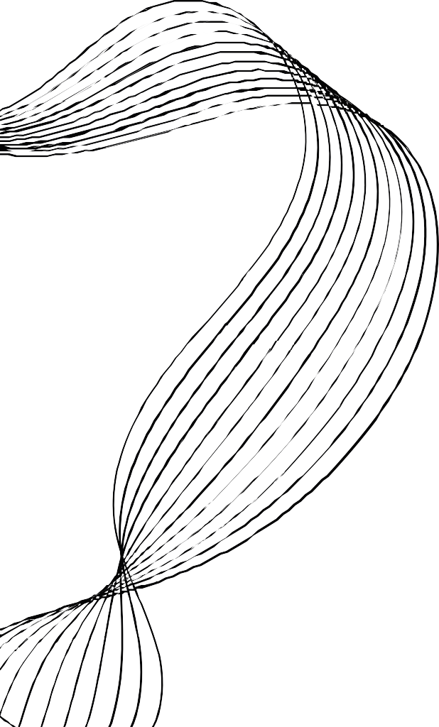**Roll no** :-- 2101331540091

**Date** :-- 10 Aug. 23 to10 sep. 23



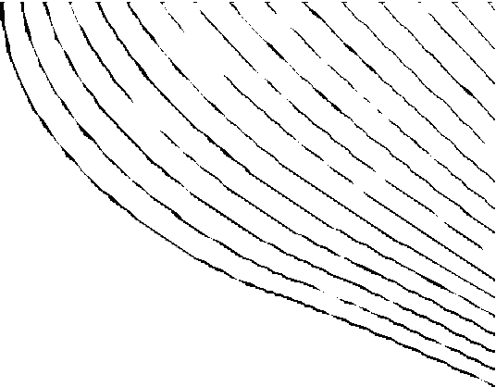COURSE CONTENTS

INTRODUCTION OF WEB ( WORLD WIDE WEB)

**01**

**02**

**03**

**04**

**05**

**06**

HTML

CSS

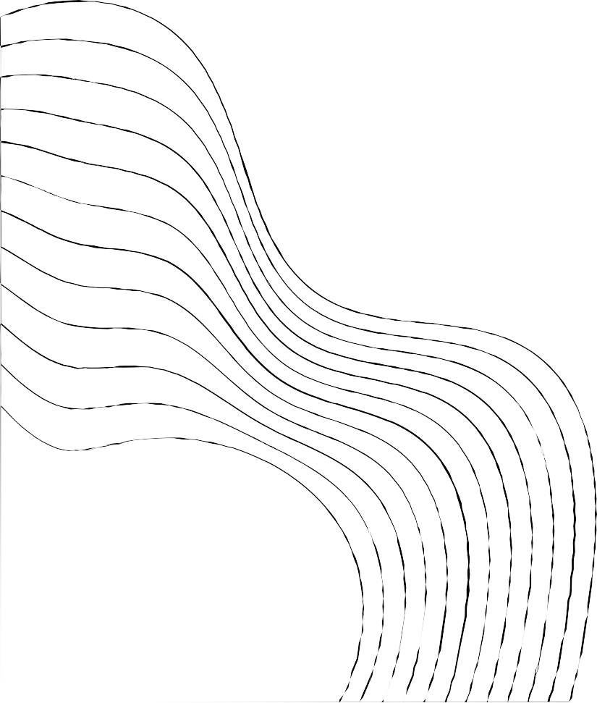BOOTSTRAP 4 SQL

Python



**INTRODUCTION OF WEB**

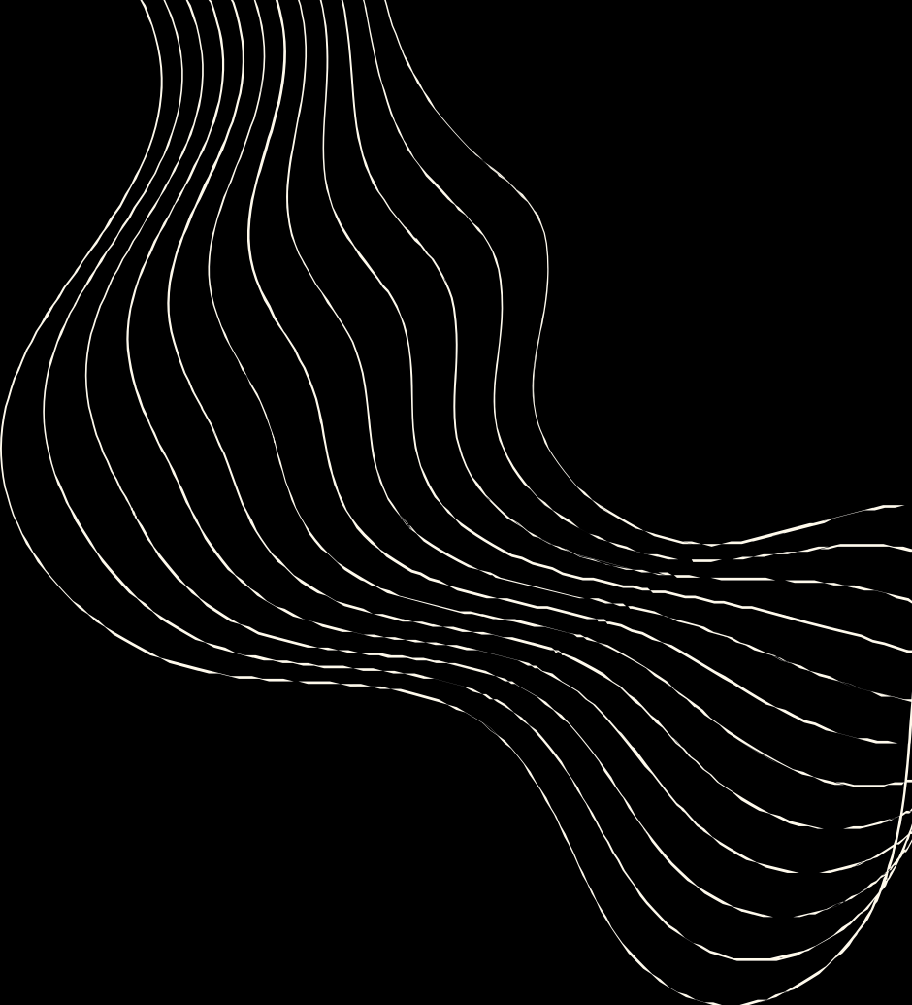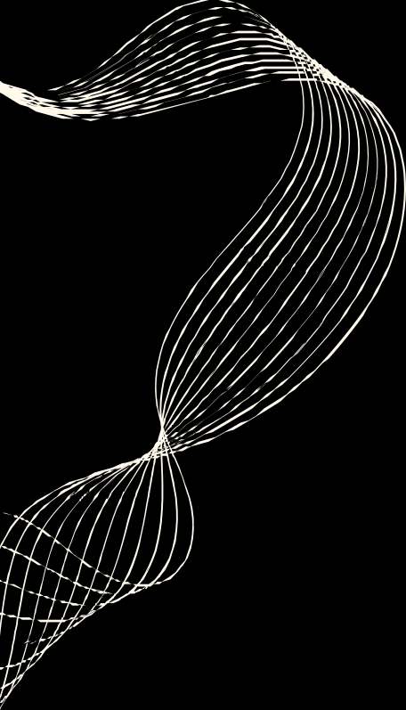

WHAT IS WEB (WWW)

The world wide web was originally designed in 1991 by Tim Berners-lee in switzerland WWW means intrlinking of web pages.

Webpage are written in HTML(Hyper Text Markup Language)

WWW is also called internet or the web.All the webpage, videos, images are accessed via a web browser on the internet with use of URL(Uniform Resource Locator)



**WHAT DO YOU NEED FOR THIS COURSE?**



*Google chrome*



**Web browser (Google**

**Chrome, Mozilla firefox)**

**Text editor(Notepad++**

**,Notepad)**

# Notepad++

*Mozilla firefox*



# Notepad





**CONTENTS OF HTML**

## INTODUCTION :-

Structure Lists Links Images Table Form



**STRUCTURE OF WEB PAGE What is html**

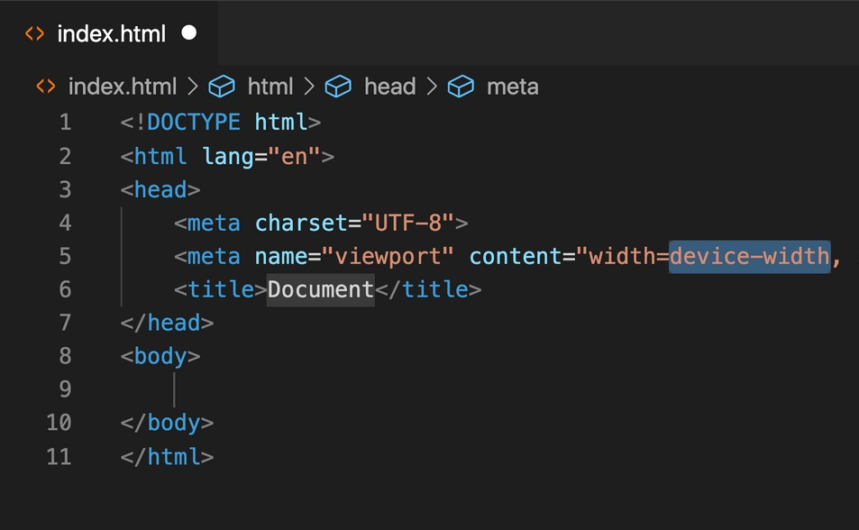Full form of HTML is Hyper Text Markup Language.

it is the main language which is used to create web page on the internet.<>are used in html,So this is called markup language.We can checkcoding of any web page by checking it‘s page source.



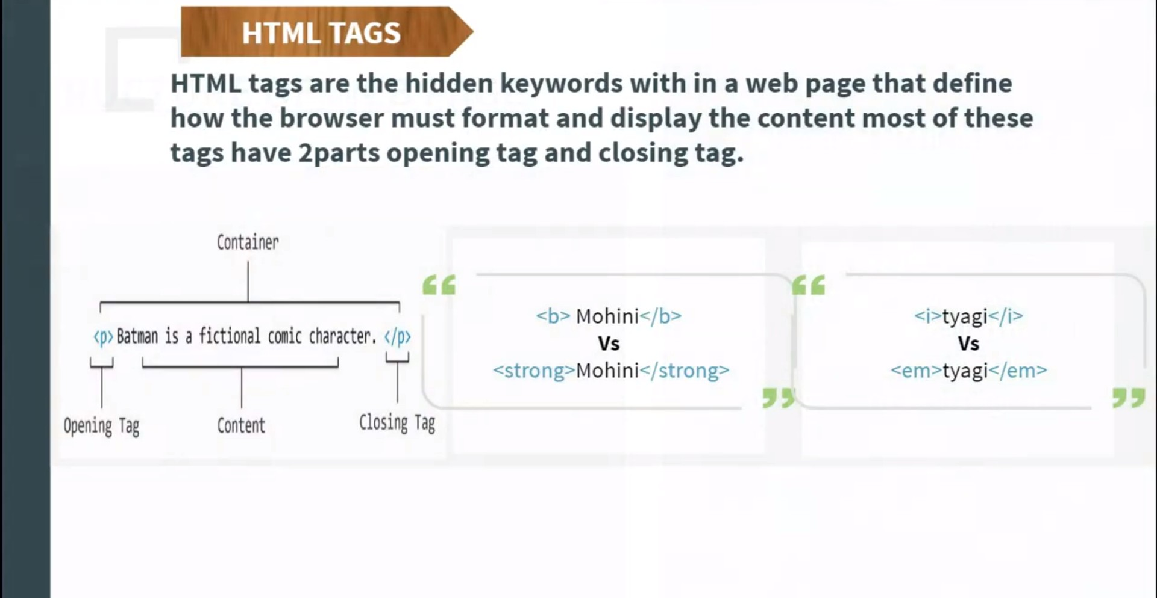



**LISTs TAG**

1. UNORDER LIST <ul>...</ul>
2. 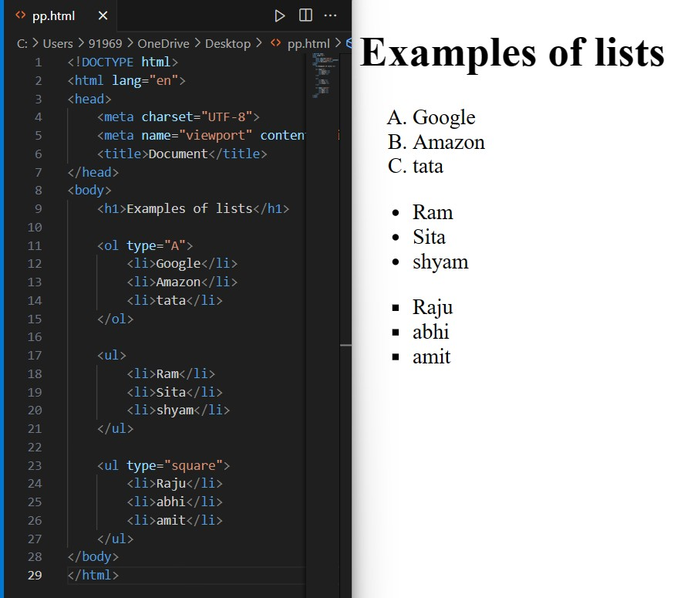ORDER LIST <ol>...</ol> 4. **Nesting**

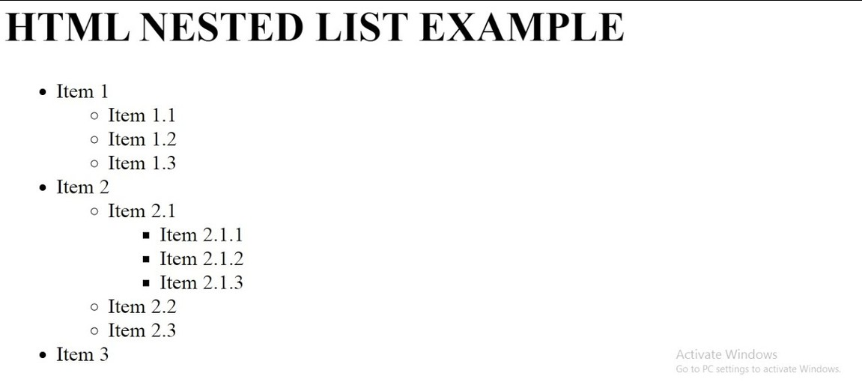Nesting typically refers to the practice of placing one element inside another, often in a hierarchical or nested structure. In programming, it commonly refers to the arrangement of code blocks within one another, and in biology, it can describe the creation and maintenance of a nest by animals.

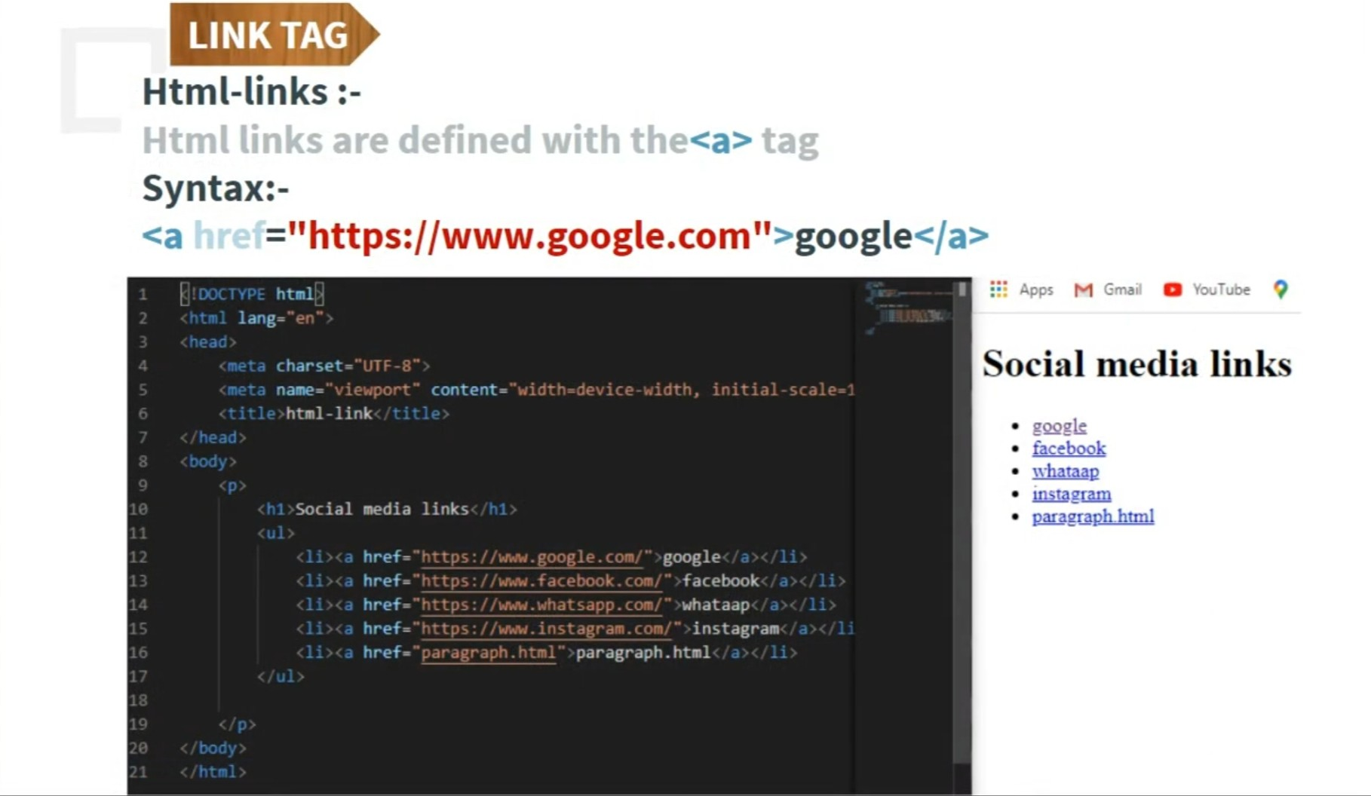

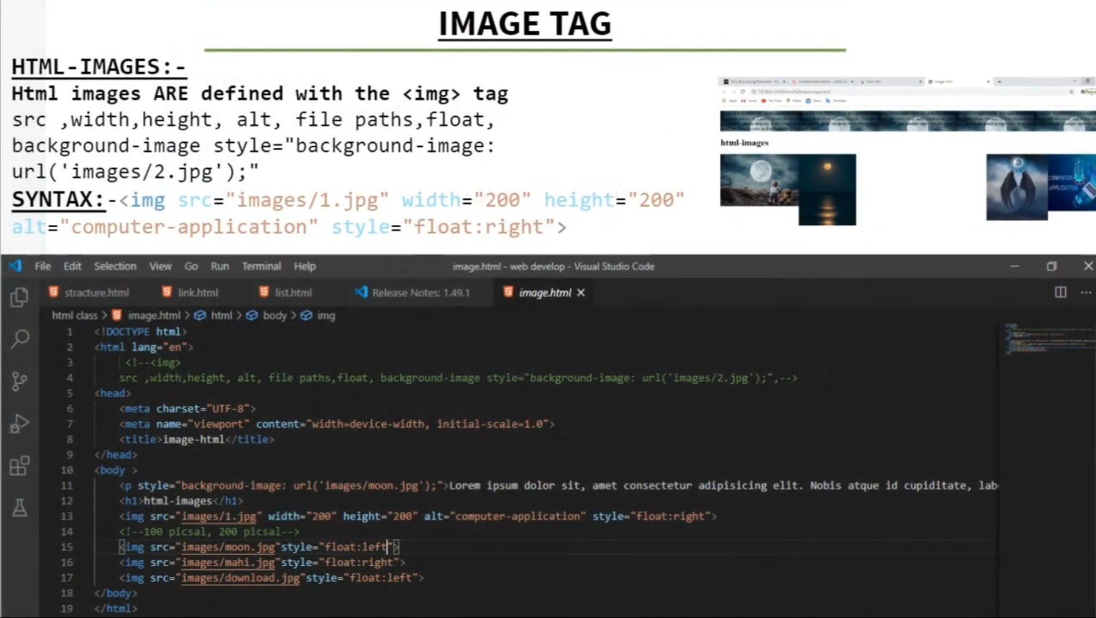



## Form output

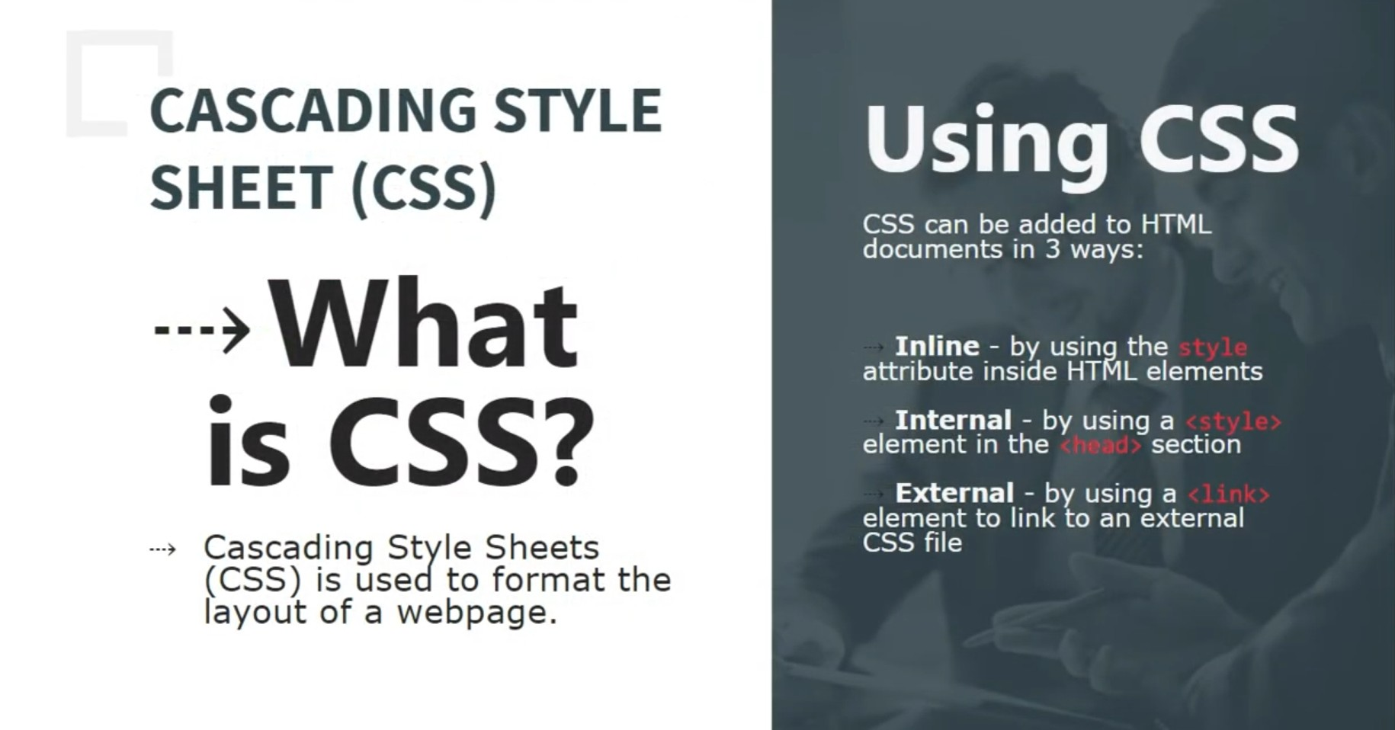

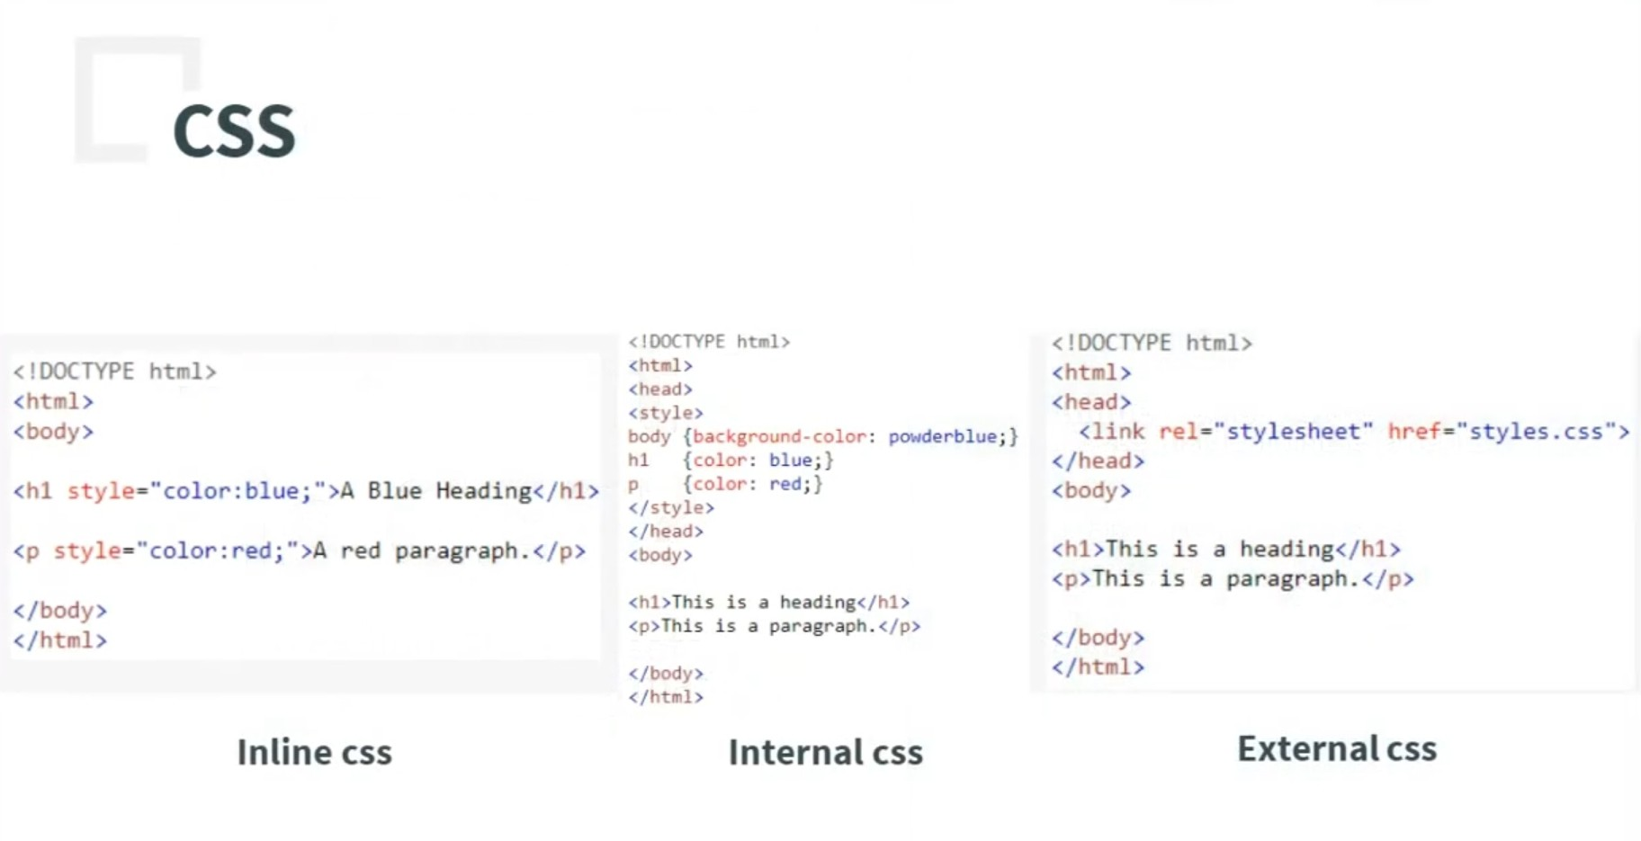

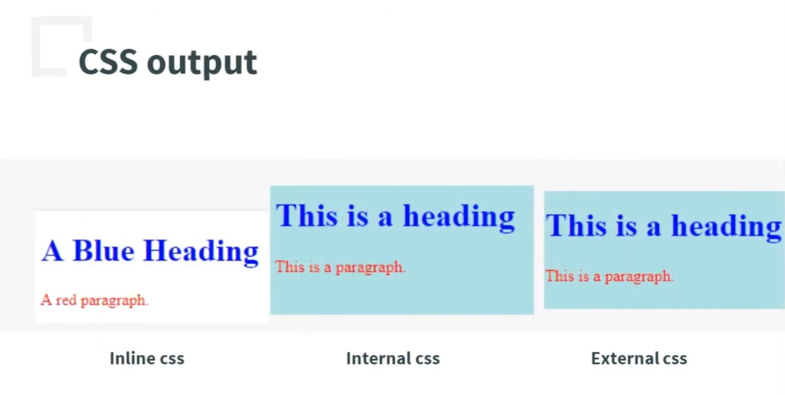

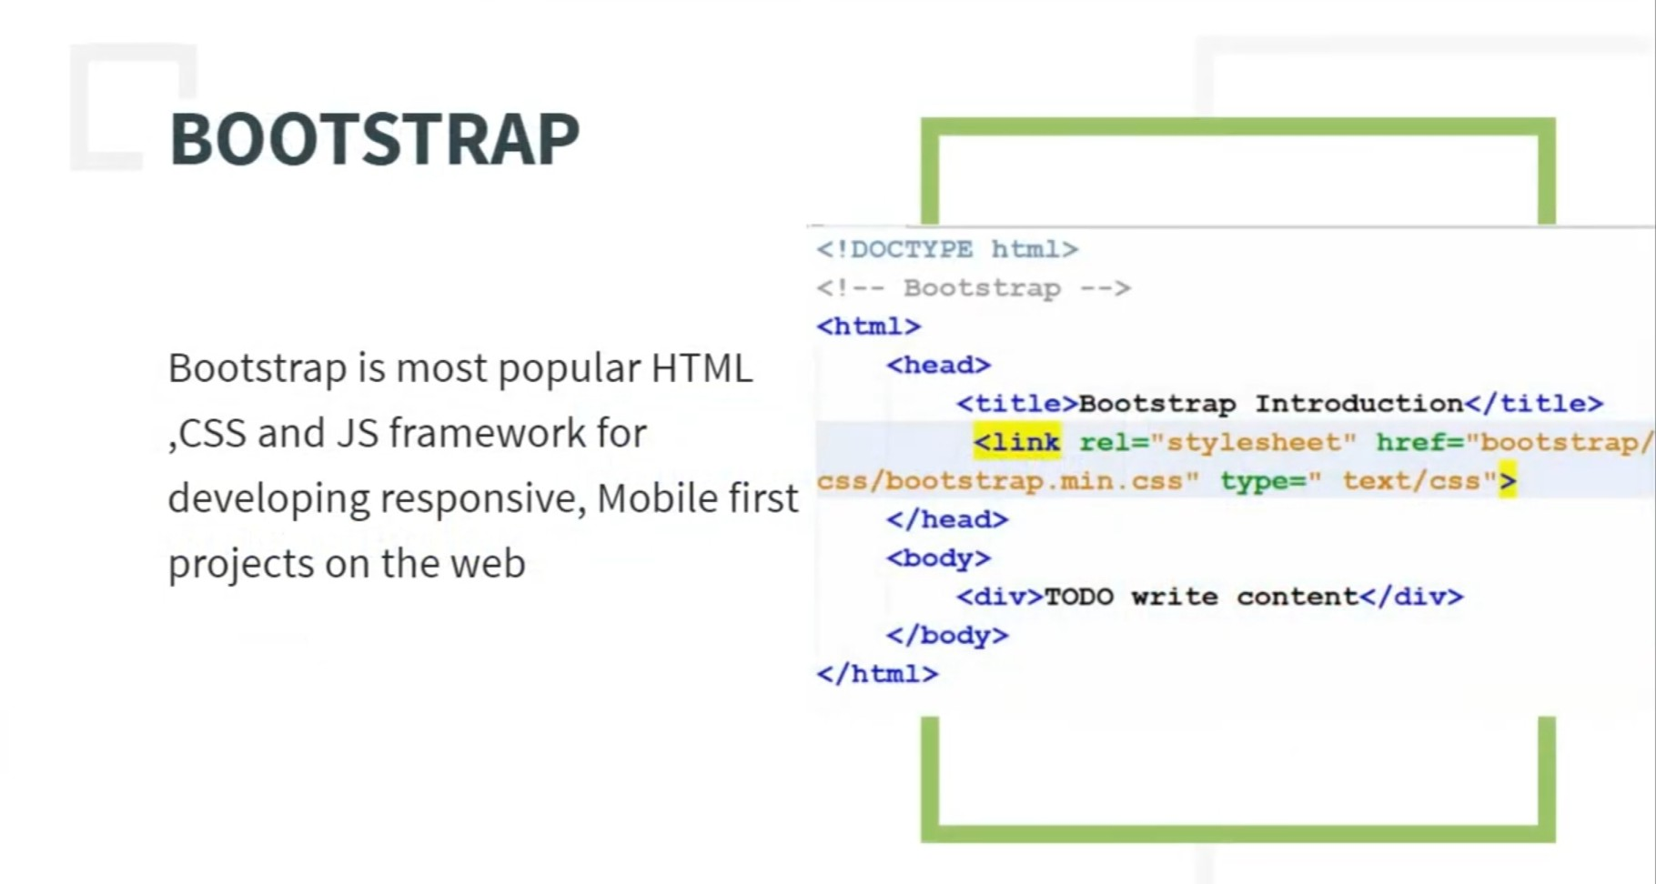

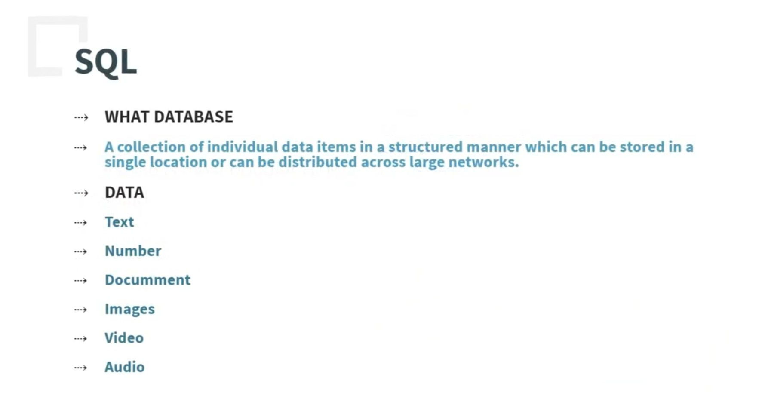

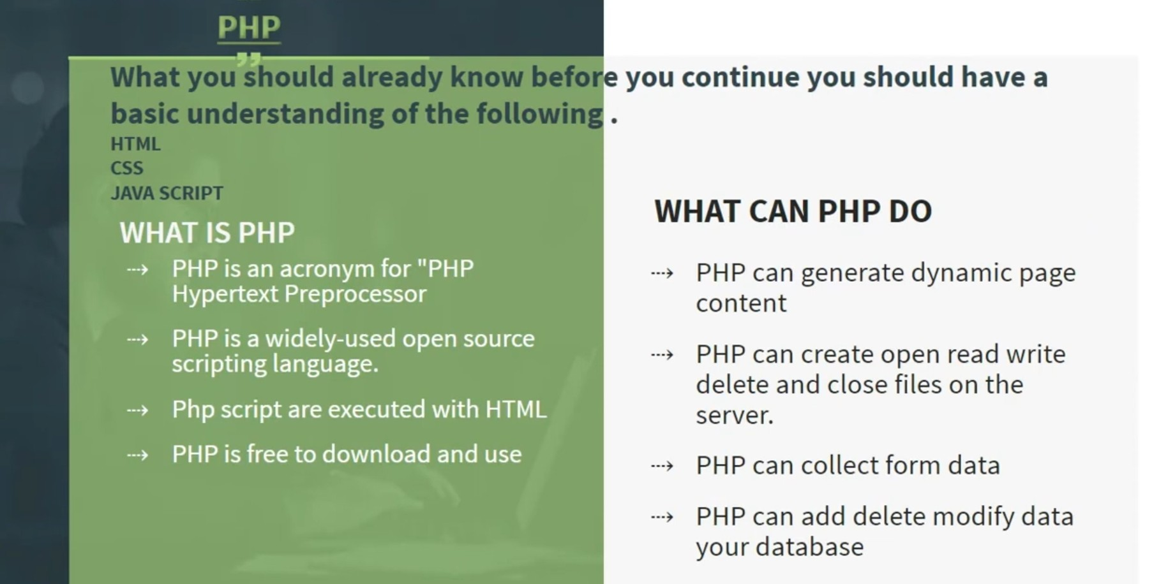

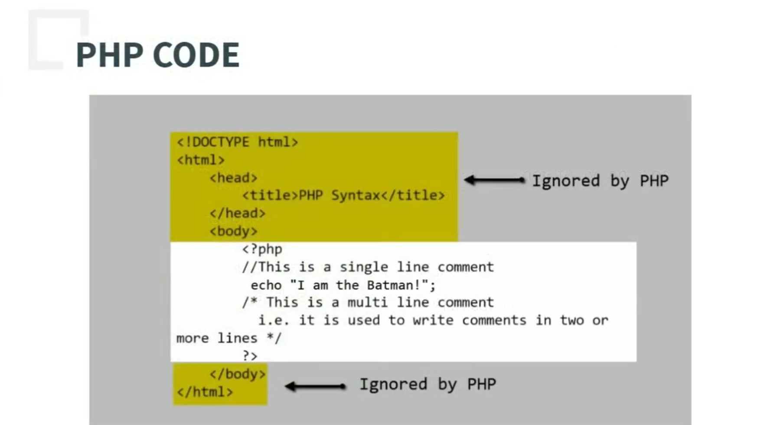



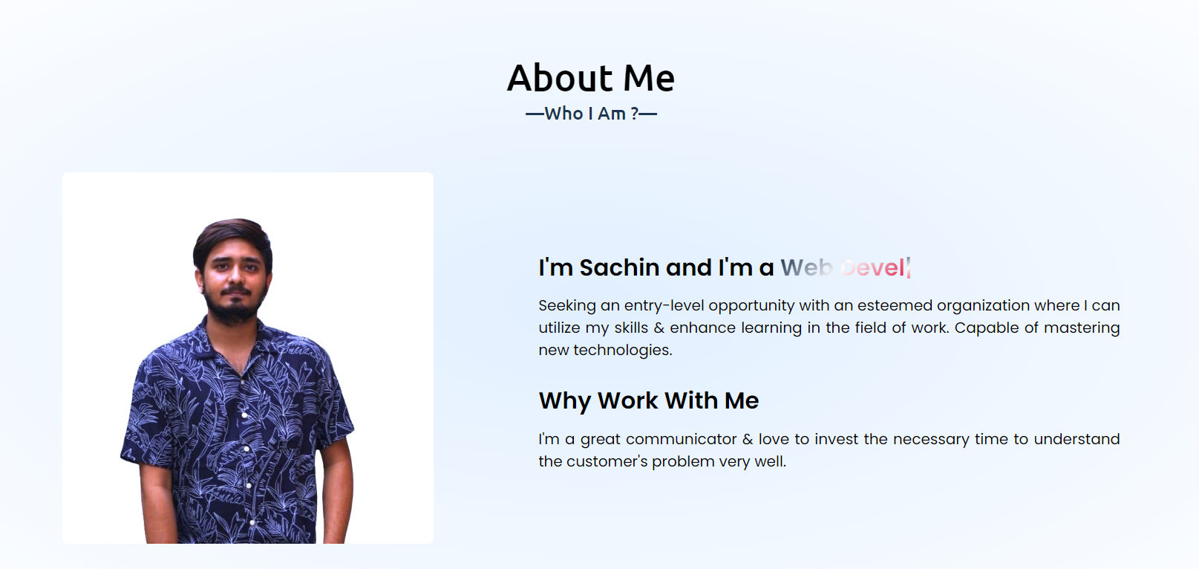

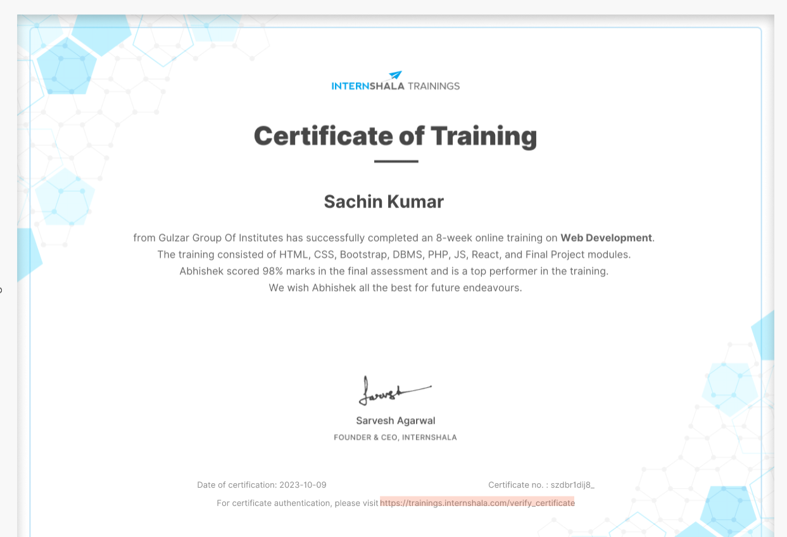





**THANK YOU**